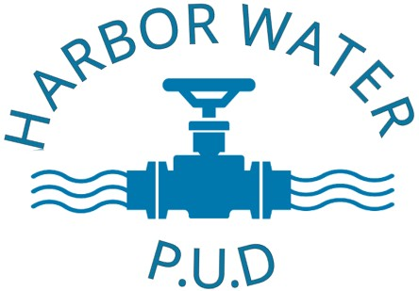

**New Service**

**Service Start Request**

Please complete this form to Start a Service Account with Harbor Water P.U.D.

98069 W. Benham Lane

Harbor, OR 97415

1. Bills are mailed no later than the 5th working day of the month.
2. Bills are due by the 23rd of each month.
3. Accounts become delinquent if not paid by the 23rd of each month.
4. Accounts that become delinquent will be assessed a $15.00 late fee.
5. Shut-off notices are sent at least 10 days prior to shut-off date (in the mail to the billing address on file). The notice will indicate when shut off will occur, if payment has not been received by the notice date a $35.00 shut-off fee will be assessed ($65.00 for after hours reconnection)
6. Harbor Water is not responsible for any lost/stolen/missing mail, this agreement is your acknowledgement Harbor water is not responsible for late delivery of any “Auto Payment/Bill Pay” made through a third party or bank. (If using these please be aware that it can take our office up to 3 weeks to receive payment.)
7. Each account requires a Deposit to open ($100 Res. $150 Comm.)
8. Deposits will remain with the service account until the account has been closed. Deposits will be applied to final bills. Remaining credit will be returned by check within 2-4 weeks to the listed billing address on the account.
9. Account holders will comply with utility rules, regulations and rate schedules set forth by the Harbor Water P.U.D Board.

Service Address:____________________________ Billing/Mailing Address:___________________________________

Start Service Date:__________________________

ACCOUNT HOLDER INFORMATION RENTER/OCCUPANT INFORMATION

Name: ________________________________________ Name: ________________________________________

Phone #: ___________________________________ Phone #: ___________________________________

Email: ________________________________________ Email: ________________________________________

Property/Landowner: ___________________________ Renter/Occupant: _______________________________

I certify that the above information is true, and I am responsible for payment of the service account. I understand that Harbor Water has no control or oversight of any payment agreement made between landowners/renters/lessees.

All water service Accounts will have the current property owner’s information (Name and contact information) regardless of who is paying the bill (rent/lease/live in).

If at any point the service account becomes delinquent, all accrued charges and fees will be the landowner’s responsibility regardless of current occupants’ status.

Print Name:____________________________________ Signature:____________________________________

For any questions or concerns please call the office: (541)469-3011 or visit our website: *harborwaterpud.com*

Office Hours: 9:00am – 2:00pm Monday-Thursday (Closed for all major Holidays)