New Service
- Bills are due by the 23rd of each month.
- Bills are mailed no later than the 5th working day of the month.
- Accounts become delinquent if not paid by the 23rd of each month and will incur a $15.00 late fee.
- Shut-off notices are Mailed at least 10 days prior to shut-off date in the mail, to the listed billing address on the account. The notice will indicate when shut-off will occur.
- If payment has not been received by the notice date a $35.00 shut-off fee will be assessed
($65.00 for after-hours reconnection)
- Please ensure to keep contact info updated. Harbor Water is not responsible for any lost/stolen/missing mail, this agreement is your acknowledgement Harbor water is not responsible for late delivery of any “Auto Payment/Bill Pay” made through a third party or bank. (If using these please be aware that it can take our office up to 3 weeks to receive payment.)
- Each account requires a Deposit to open. Deposits will remain with the service account until the account has been closed.
- Deposits will be applied to final bills. Remaining credit will be returned by check within 2-4 weeks to the listed billing address on the account.
- Account holders will comply with utility rules, regulations and rate schedules set forth by the Harbor Water P.U.D Board.
- Maintenance and accessibility of Water utility box and customer side service line is the responsibility of the customer/property owner.
- Customers are prohibited from tampering with Harbor water’s side (utility side) of service at the meter.
- All water service Accounts will have the current property owner’s information (Name and contact information) regardless of who is paying the bill (rent/lease/live in).

PROPERTY/LANDOWNER INFORMATION:
Service Address: | Harbor, OR 97415
Billing/Mailing Address:
Service Start Date:
Name(s):
Phone #’s:
Billing option:  Email: | Paper Copy Electronic AutoPay  Default option is electronic
I certify that I have read and understand the rules listed and that I am responsible for payment of the service account.
I understand that Harbor Water has no control or oversight of any payment agreement made between landowners/renters/lessees or property management groups.
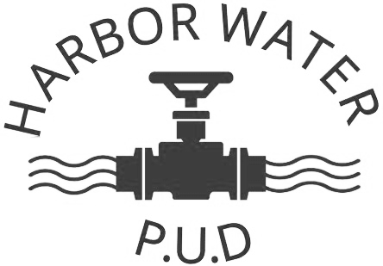
All provided information listed is true and accurate.

Signature: ___________________________________

Deposit amount Paid: $_______________ Reference: ___________________
Account #: ___________________

Occupant/Renter/Property management INFORMATION:
Billing/Mailing Address
Service Start Date
Name:
Joint Acct Name:
Phone #’s: | Default option is electronic
Billing option:  Email: | Paper Copy Electronic AutoPay

I understand that Harbor Water has no control or oversight of any payment agreement made between landowners/renters/lessees and that it’s the responsibility of the owner and occupant (rent/lease/live in) to notify Harbor Water PUD of any changes to billing information/status.

- All water service Accounts will have the current property owner’s information (Name and contact information) regardless of who is paying the bill (rent/lease/live in).

- If at any point the service account becomes delinquent, all accrued charges and fees will be the landowner’s responsibility regardless of current occupants’ status.

Signature: ____________________________________

